**Door Lock system using RFID with Arduino UNO**

This documentation provides a comprehensive guide for creating an RFID-based door lock system using an Arduino Uno. The project is designed to enhance security and access control in various settings, such as homes, offices, or any location where restricted entry is required.

**Hardware Components:**

* **Arduino Uno**
* **RFID Module (e.g., MFRC522)**
* **Servo Motor**
* **RFID Cards**
* **Jumper Wires**

**Software Requirements:**

1. Arduino IDE.

2. Arduino libraries:

i. <SPI.h>

ii. <MFRC522.h>

iii. <Servo.h>

**Step 1: Install Required Libraries**

- In the Arduino IDE, go to "Sketch" > "Include Library" > "Manage Libraries."

- Search for and install the following libraries:

- SPI.h

- MFRC522.h

- Servo.h

**Step 2: Wiring the Components**

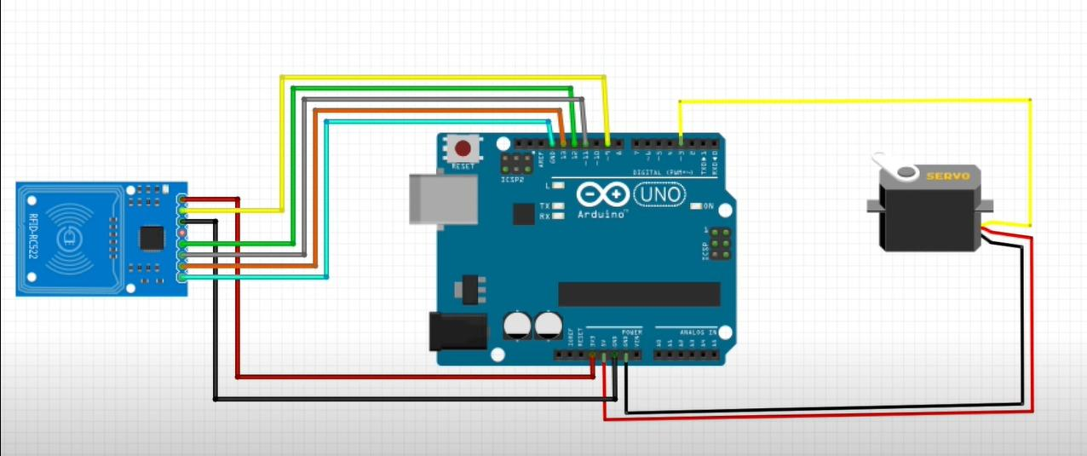

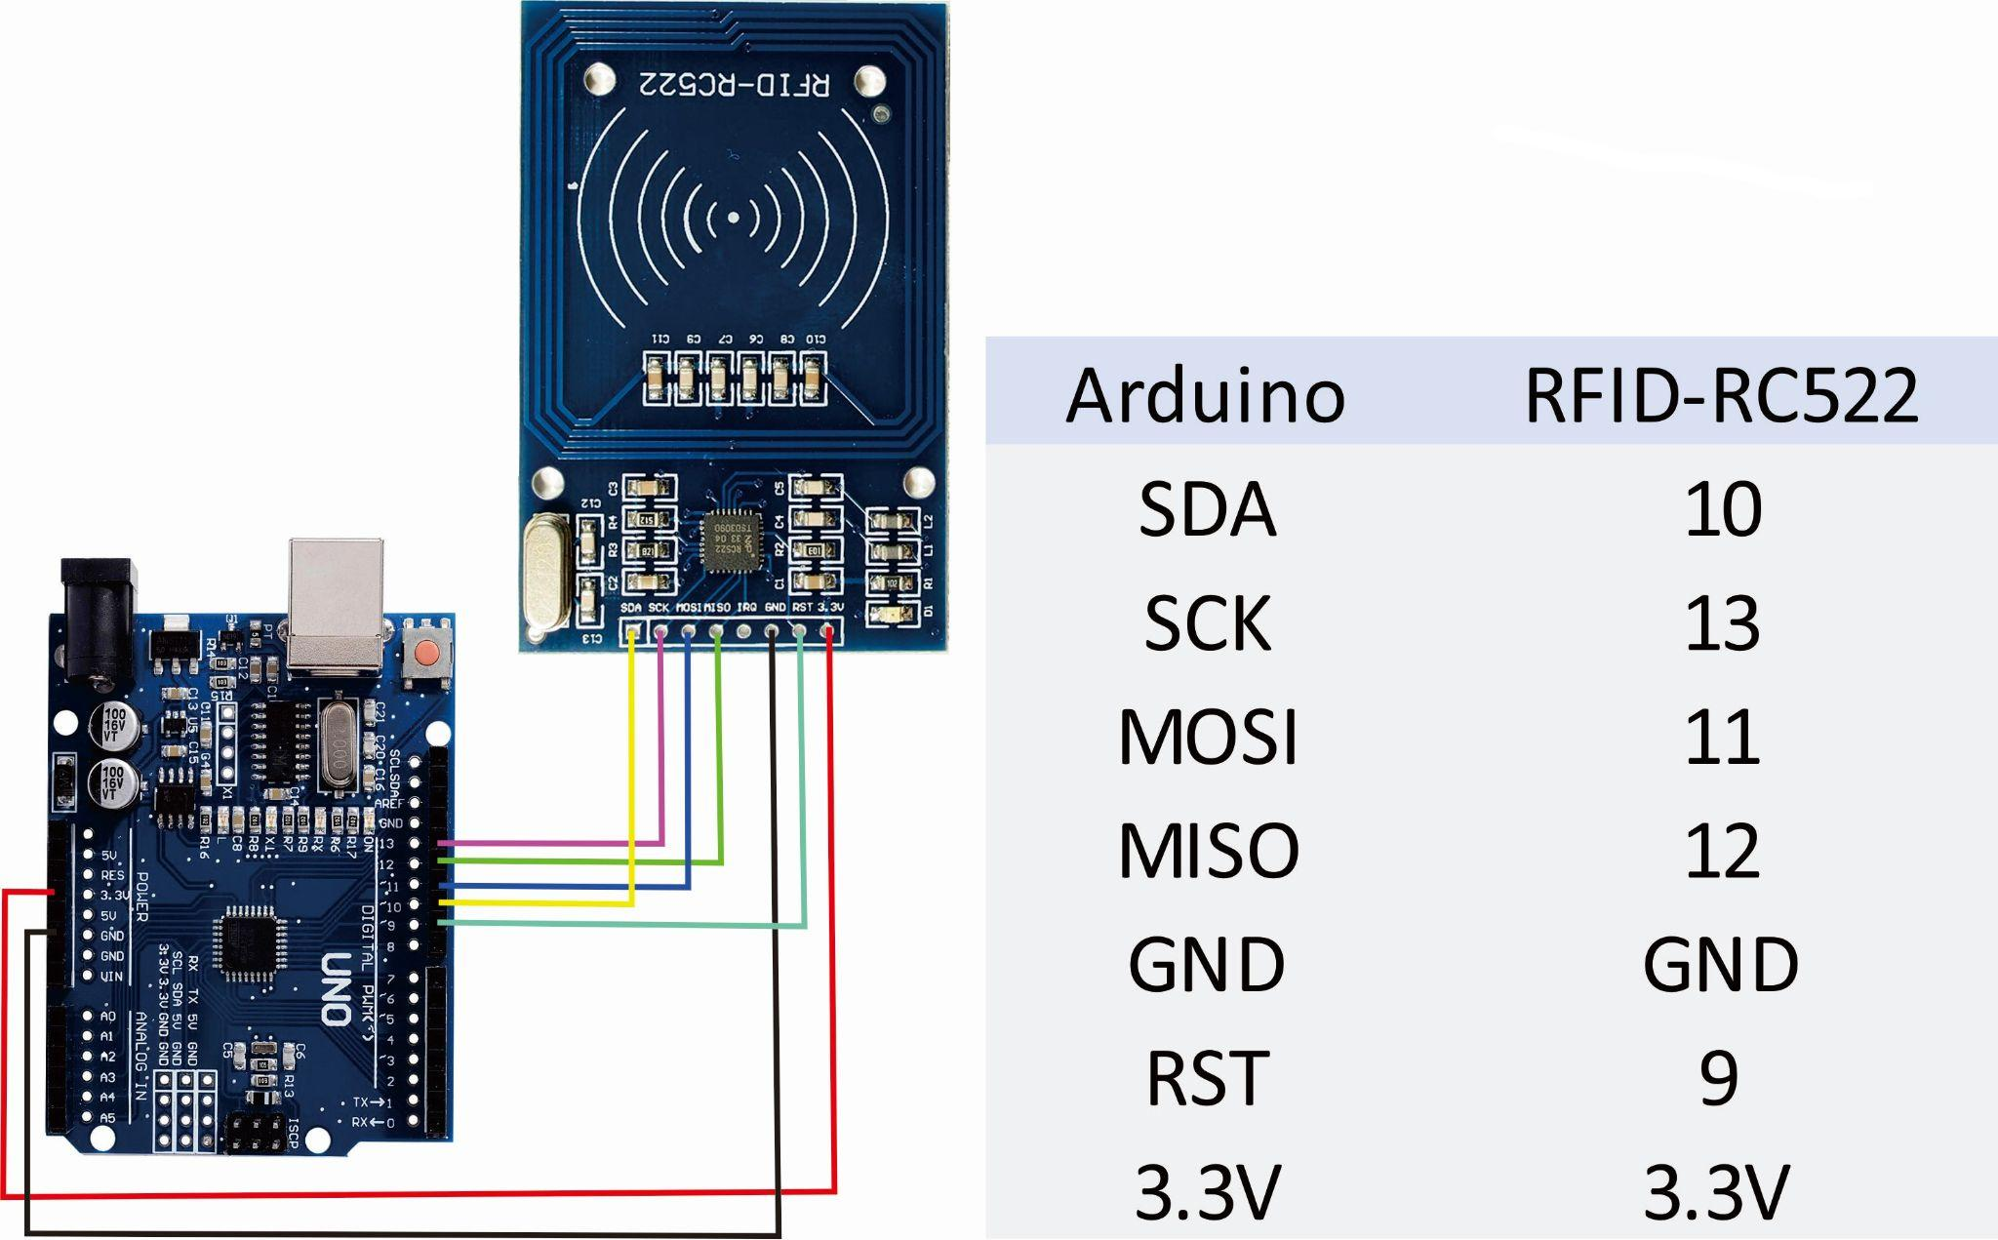

**Step 3: Code**

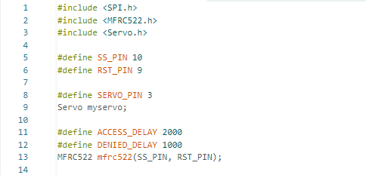

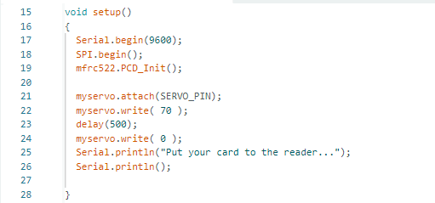

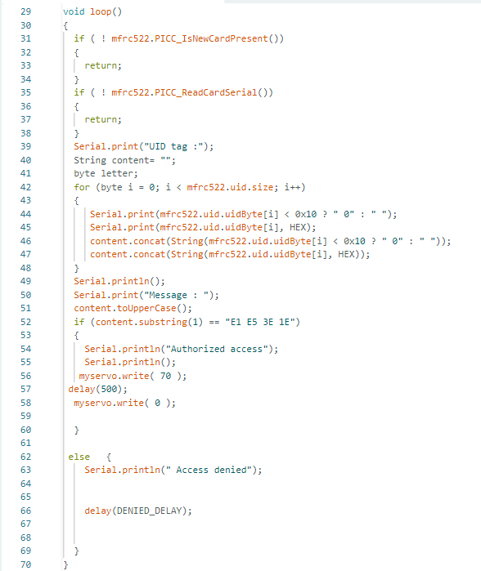

**Step 4 : Get the output from the Serial monitor**

